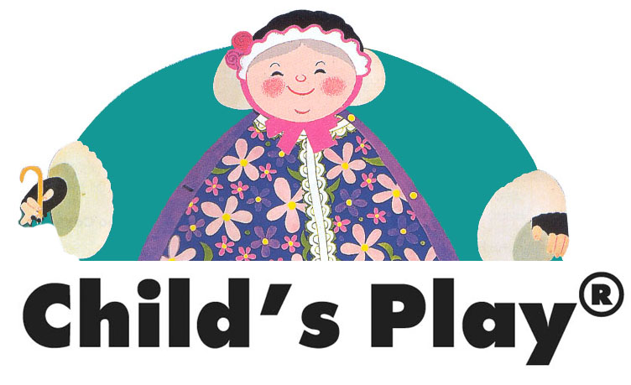
Become a Child’s Play Representative
and earn up to 35% commission

Child’s Play is an internationally renowned publisher of educational books, games and associated materials for pre-school and primary school children.

The aim of having Child’s Play representatives is to enable our products to be offered directly to the customer in an informal atmosphere.

Representatives can hold Child’s Play presentations anywhere they wish! - Playgroups, community settings, libraries, nurseries, schools even there own homes! The intention is to create an environment where a mix of attendees have the opportunity to discuss, examine and handle our products before selecting what they purchase. They also have the chance to observe how children respond to our products and explore how they are specifically designed to help children learn through play.

We provide a starter kit with a value of £200 for which we ask £75 – add to your kit anytime at half price.
Full support is given from head office.

If you are interested in joining us, or would like more information,
please contact:

Amy Griffiths on 01793 616286.
e-mail: Amy@childs-play.com

Visit our website: www.childs-play.com

